* 1. **Interactive Diagram**
     1. **Web Application**
        + 1. Customer
          2. Staff

Create new contract

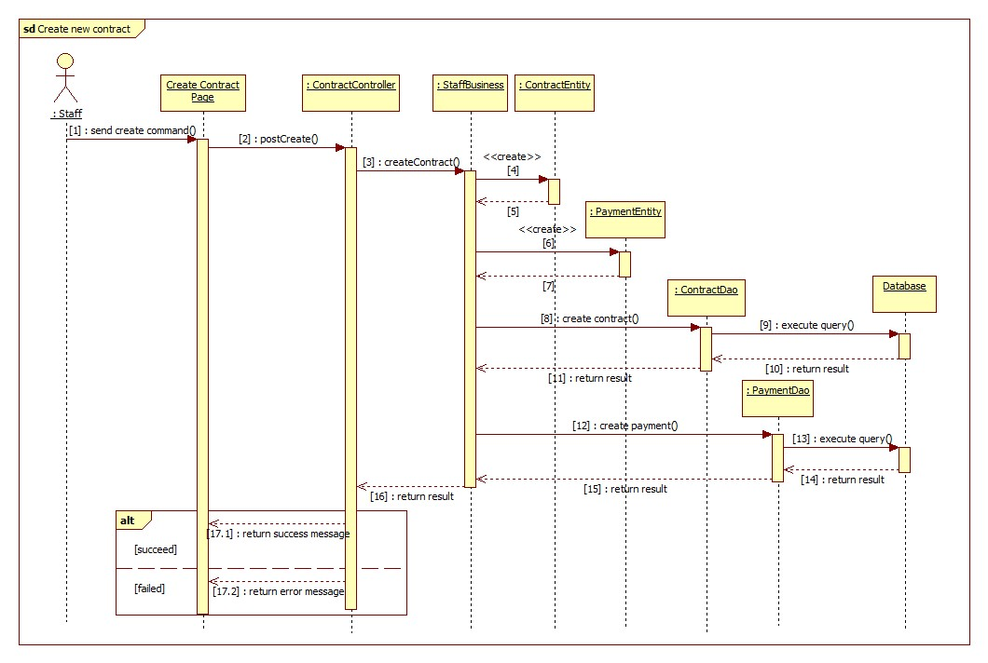

Renew contract

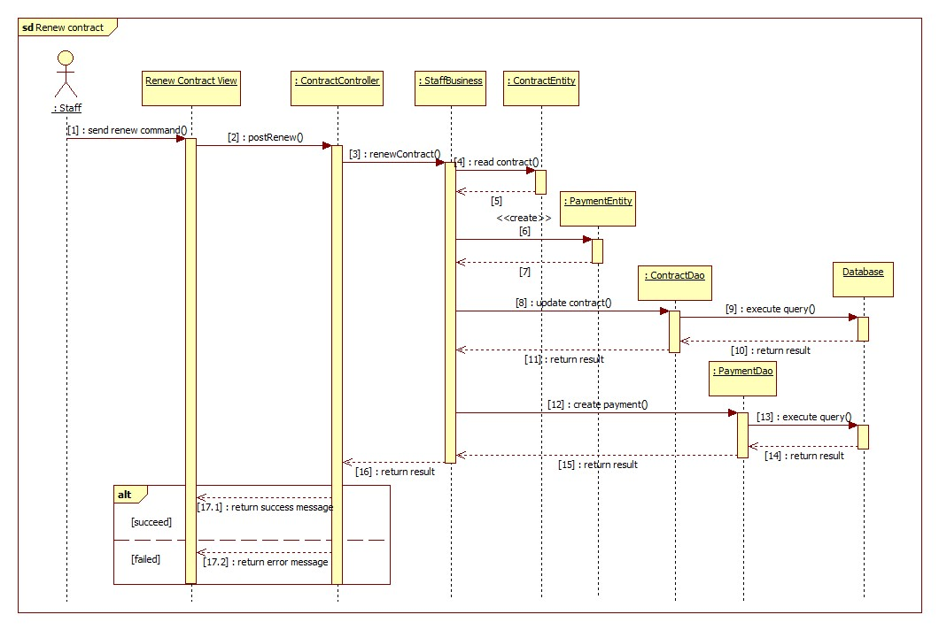

Cancel contract

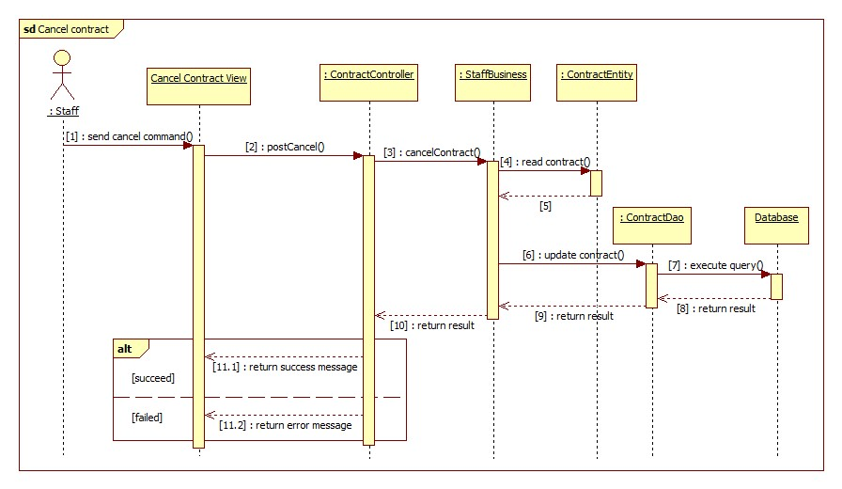

## User Interface Design

### Web application Design

#### **Customer Interface Design**

#### **Staff Interface Design**

##### **Staff home page**

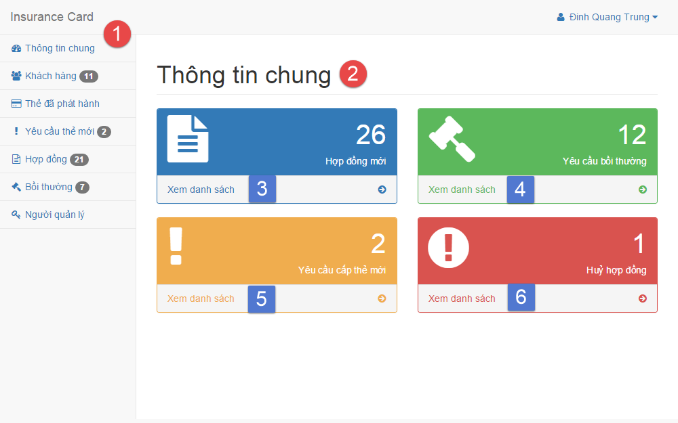

**Fields**

|  |  |  |  |  |  |  |  |
| --- | --- | --- | --- | --- | --- | --- | --- |
| **No** | **Field Name** | **Description** | **Read only** | **Mandatory** | **Control Type** | **Data Type** | **Length** |
| 1 | Menu | Navigation bar | Yes | Yes | Menu bar | N/A | N/A |
| 2 | Title | Title of the page | Yes | Yes | Label | N/A | N/A |

**Button/Hyperlinks**

|  |  |  |  |  |
| --- | --- | --- | --- | --- |
| **No** | **Function** | **Description** | **Validation** | **Outcome** |
| 3 | viewContract | List all contract | N/A | Transfer to list contract page |
| 4 | viewCompensation | List all compensation | N/A | Transfer to list compensation page |
| 5 | viewNewCardReq | List all new card request | N/A | Transfer to list new card request page |
| 6 | viewCancelContract | List all cancel contract request | N/A | Transfer to list contract page |

##### **Manage customer**

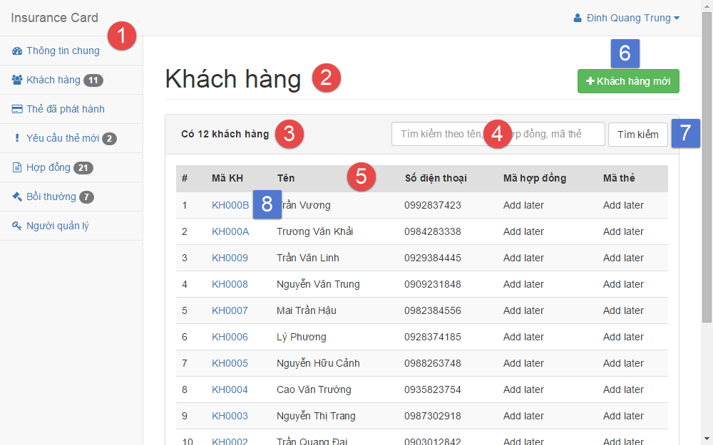

**Fields**

|  |  |  |  |  |  |  |  |
| --- | --- | --- | --- | --- | --- | --- | --- |
| **No** | **Field Name** | **Description** | **Read only** | **Mandatory** | **Control Type** | **Data Type** | **Length** |
| 1 | Menu | Navigation bar | Yes | Yes | Menu bar | N/A | N/A |
| 2 | Title | Title of the page | Yes | Yes | Label | N/A | N/A |
| 3 | Number | Number of available customer | Yes | No | Label | N/A | N/A |
| 4 | txtSearchValue | Fill search keyword | No | Yes | Textbox | String | N/A |
| 5 | Table | Table of available customer | Yes | Yes | Table | N/A | N/A |

**Button/Hyperlinks**

|  |  |  |  |  |
| --- | --- | --- | --- | --- |
| **No** | **Function** | **Description** | **Validation** | **Outcome** |
| 6 | btnCreate | Create new customer | N/A | Transfer to create new customer page |
| 7 | btnSearch | Search by input keyword | N/A | Transfer to search result page |
| 8 | customerDetail | View customer detail | N/A | Transfer to customer detail page |

##### **Create customer**

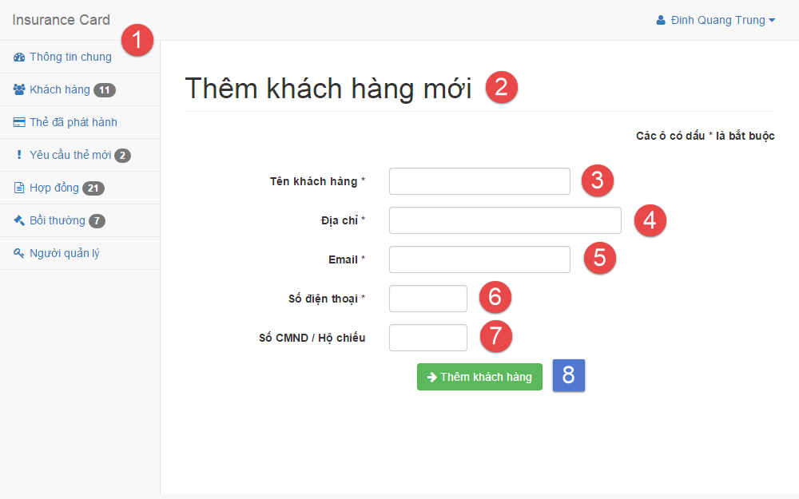

**Fields**

|  |  |  |  |  |  |  |  |
| --- | --- | --- | --- | --- | --- | --- | --- |
| **No** | **Field Name** | **Description** | **Read only** | **Mandatory** | **Control Type** | **Data Type** | **Length** |
| 1 | Menu | Navigation bar | Yes | Yes | Menu bar | N/A | N/A |
| 2 | Title | Title of the page | Yes | Yes | Label | N/A | N/A |
| 3 | txtName | Fill customer name | No | Yes | Textbox | String | 3 – 80 |
| 4 | txtAddress | Fill address | No | Yes | Textbox | String | 3 – 250 |
| 5 | txtEmail | Fill email | No | Yes | Textbox | String | 3 – 250 |
| 6 | txtPhone | Fill phone | No | Yes | Textbox | Integer | 8 – 15 |
| 7 | txtPersonal ID | Fill personal ID | No | No | Textbox | Integer | 8 – 15 |

**Button/Hyperlinks**

|  |  |  |  |  |
| --- | --- | --- | --- | --- |
| **No** | **Function** | **Description** | **Validation** | **Outcome** |
| 8 | btnCreate | Create new customer | N/A | Transfer to create new customer successful page |

##### **Manage contract**

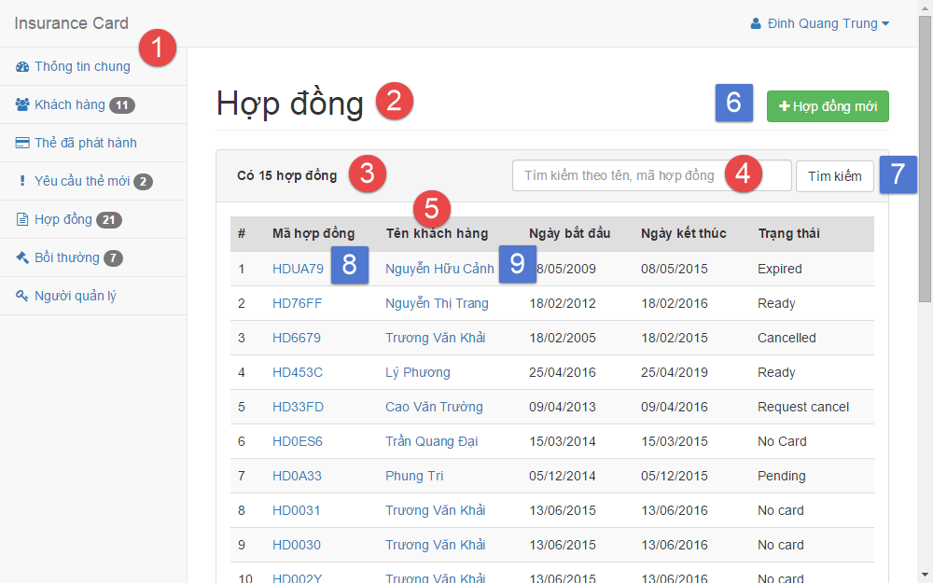

**Fields**

|  |  |  |  |  |  |  |  |
| --- | --- | --- | --- | --- | --- | --- | --- |
| **No** | **Field Name** | **Description** | **Read only** | **Mandatory** | **Control Type** | **Data Type** | **Length** |
| 1 | Menu | Navigation bar | Yes | Yes | Menu bar | N/A | N/A |
| 2 | Title | Title of the page | Yes | Yes | Label | N/A | N/A |
| 3 | Number | Number of available contract | Yes | No | Label | N/A | N/A |
| 4 | txtSearchValue | Fill search keyword | No | Yes | Textbox | String | N/A |
| 5 | Table | Table of available customer | Yes | Yes | Table | N/A | N/A |

**Button/Hyperlinks**

|  |  |  |  |  |
| --- | --- | --- | --- | --- |
| **No** | **Function** | **Description** | **Validation** | **Outcome** |
| 6 | btnCreate | Create new contract | N/A | Transfer to create new contract page |
| 7 | btnSearch | Search by input keyword | N/A | Transfer to search result page |
| 8 | contractDetail | View contract detail | N/A | Transfer to contract detail page |
| 9 | customerDetail | View customer detail | N/A | Transfer to customer detail page |

##### **Create contract**

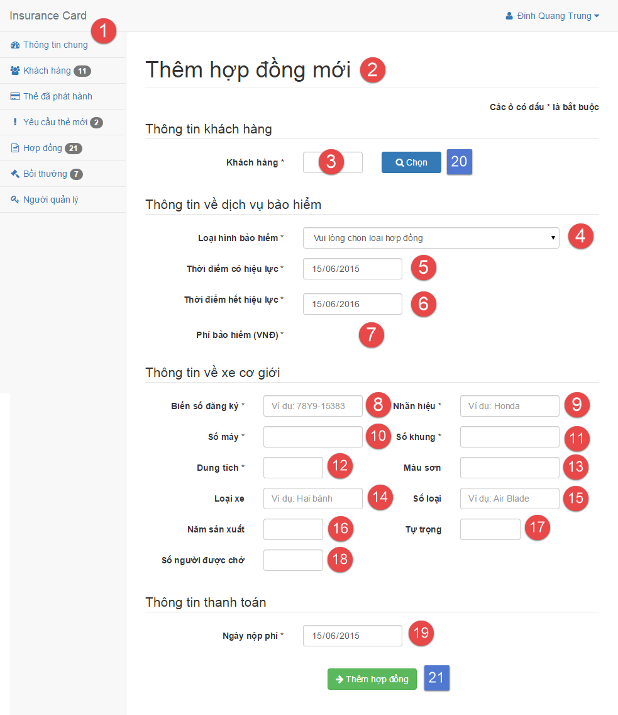

**Fields**

|  |  |  |  |  |  |  |  |
| --- | --- | --- | --- | --- | --- | --- | --- |
| **No** | **Field Name** | **Description** | **Read only** | **Mandatory** | **Control Type** | **Data Type** | **Length** |
| 1 | Menu | Navigation bar | Yes | Yes | Menu bar | N/A | N/A |
| 2 | Title | Title of the page | Yes | Yes | Label | N/A | N/A |
| 3 | txtCustomerCode | Fill customer code | No | Yes | Textbox | String | 6 |
| 4 | ddlContractType | Select contract type | No | Yes | Select | N/A | N/A |
| 5 | txtStartDate | Select start date | No | Yes | Date input form | N/A | N/A |
| 6 | txtExpiredDate | Select expired date | No | Yes | Date input form | N/A | N/A |
| 7 | txtContractFee | Contract fee | Yes | Yes | Label | N/A | N/A |
| 8 | txtPlate | Fill vehicle plate | No | Yes | Textbox | String | 4 – 15 |
| 9 | txtBrand | Fill vehicle brand | No | Yes | Textbox | String | 2 – 20 |
| 10 | txtEngine | Fill vehicle engine | No | Yes | Textbox | String | 2 – 20 |
| 11 | txtChassis | Fill vehicle chassis | No | Yes | Textbox | String | 2 – 20 |
| 12 | txtCapacity | Fill vehicle capacity | No | Yes | Textbox | String | 2 – 20 |
| 13 | txtColor | Fill vehicle color | No | No | Textbox | String | 2 – 20 |
| 14 | txtType | Fill vehicle type | No | No | Textbox | String | 2 – 20 |
| 15 | txtModel code | Fill vehicle model code | No | No | Textbox | String | 2 – 20 |
| 16 | txtYearOfMan | Fill vehicle year of manufacture | No | No | Textbox | String | 4 |
| 17 | txtWeight | Fill vehicle empty weight | No | No | Textbox | String | 1 – 4 |
| 18 | txtSeatCapacity | Fill vehicle seat capacity | No | No | Textbox | String | 1 – 3 |
| 19 | txtPaidDate | Select paid contract fee date | No | Yes | Date input form | N/A | N/A |

**Button/Hyperlinks**

|  |  |  |  |  |
| --- | --- | --- | --- | --- |
| **No** | **Function** | **Description** | **Validation** | **Outcome** |
| 20 | btnSelect | Select customer | N/A | Transfer to select customer modal |
| 21 | btnCreate | Create new contract | N/A | Transfer to create new contract successful page |

##### **Renew contract**

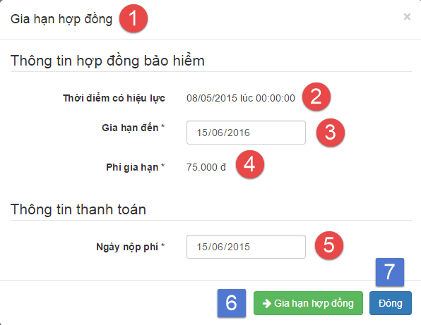

**Fields**

|  |  |  |  |  |  |  |  |
| --- | --- | --- | --- | --- | --- | --- | --- |
| **No** | **Field Name** | **Description** | **Read only** | **Mandatory** | **Control Type** | **Data Type** | **Length** |
| 1 | Title | Title of the modal | Yes | Yes | Label | N/A | N/A |
| 2 | Start date | Contract’s start date | Yes | Yes | Label | N/A | N/A |
| 3 | txtExpiredDate | Select expired date | No | Yes | Date input form | N/A | N/A |
| 4 | txtAmount | Renew contract fee | Yes | Yes | Label | N/A | N/A |
| 5 | txtPaidDate | Select paid contract fee date | No | Yes | Date input form | N/A | N/A |

**Button/Hyperlinks**

|  |  |  |  |  |
| --- | --- | --- | --- | --- |
| **No** | **Function** | **Description** | **Validation** | **Outcome** |
| 6 | btnRenew | Renew contract | N/A | Transfer to renew contract successful page |
| 7 | btnClose | Close modal | N/A | Transfer to contract detail page |

##### **Cancel contract**

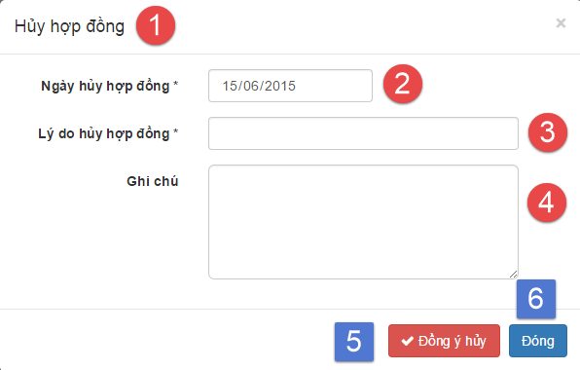

**Fields**

|  |  |  |  |  |  |  |  |
| --- | --- | --- | --- | --- | --- | --- | --- |
| **No** | **Field Name** | **Description** | **Read only** | **Mandatory** | **Control Type** | **Data Type** | **Length** |
| 1 | Title | Title of the modal | Yes | Yes | Label | N/A | N/A |
| 2 | txtCancelDate | Select cancel contract date | No | Yes | Date input form | N/A | N/A |
| 3 | txtCancelReason | Fill cancel contract reason | No | Yes | Textbox | String | 1 – 250 |
| 4 | txtCancelNote | Fill note about cancel contract | No | No | Text area | String | 1 - 2000 |

**Button/Hyperlinks**

|  |  |  |  |  |
| --- | --- | --- | --- | --- |
| **No** | **Function** | **Description** | **Validation** | **Outcome** |
| 5 | btnCancel | Cancel contract | N/A | Transfer to cancel contract successful page |
| 6 | btnClose | Close modal | N/A | Transfer to contract detail page |